|  |
| --- |
| Style Guide Mobile Site |
| Liliya Artyukh’s Portfolio Mobile Website |
| Liliya Artyukh, 300702887 |

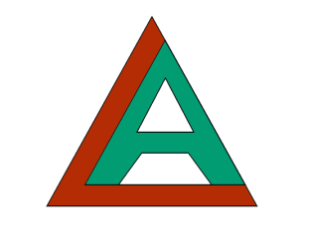

Table of Contents

[Description 2](#_Toc412792741)

[Nav Bar Functionality 3](#_Toc412792742)

[Desktop site 3](#_Toc412792743)

[Mobile Site 4](#_Toc412792744)

[Colors 5](#_Toc412792745)

[Typography 7](#_Toc412792746)

[Wireframes 8](#_Toc412792747)

[Desktop website 8](#_Toc412792748)

[Mobile Website 1](#_Toc412792749)

[Branding 2](#_Toc412792750)

[Services page 3](#_Toc412792751)

[About Me page 4](#_Toc412792752)

[Contact Me page 5](#_Toc412792753)

[Home Page 6](#_Toc412792754)

[GitHub 6](#_Toc412792755)

[References 7](#_Toc412792756)

# Description

The website is created with a goal to provide access to potential employers and other interested parties to information about work I have done.

The website has a specific purpose – it I a specially designed website for mobile phones. It acts like an extension to the existing portfolio website.

The website includes:

* Biography page with a bit of information about me
* Services page that describes what work I am capable and interested in doing
* Projects page featuring my work
* Home page that has buttons and images that link to all available pages
* Contact me page with my contact details

The website is built around mobile web design. Small amount of text, images and popup screens are the key elements of the style used.

Technology used to build the website are CSS, HTML, JQuery Mobile, third party libraries.

Best practices are used when it comes to separation of .css, .js, and .html files. Assets are organized in fodders: images and MyScripts.

# Nav Bar Functionality

## Desktop site



Bring user to home page

Bring user to biography page

Bring user to Portfolio page

Bring user to GitHub

Bring user to service page



Takes user to contact information page and email form

## Mobile Site

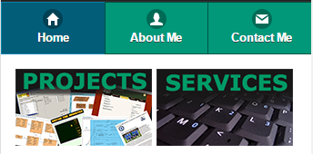

Brings user to home page

Brings user to biography page

Brings user to Portfolio page

Brings user to page with contacts

Brings user to service page

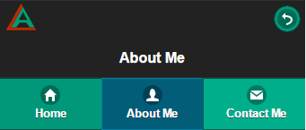

Takes user to back to previous page

# Colors

Below are the colors used in the website design.

|  |  |  |
| --- | --- | --- |
| **Where used** | **code** | **example** |
| Logo , buttons |  |  |
| Links, active page |  |  |
| Background of header |  |  |
| logo |  |  |

**Custom Swatch C**

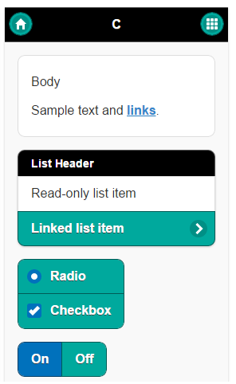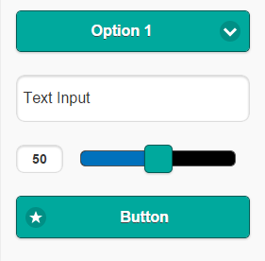

# Typography

Font for this mobile website was the default font of jQueryMobile.

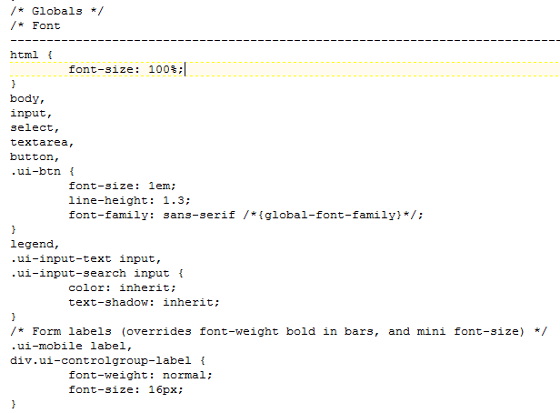

# Wireframes

## Desktop website

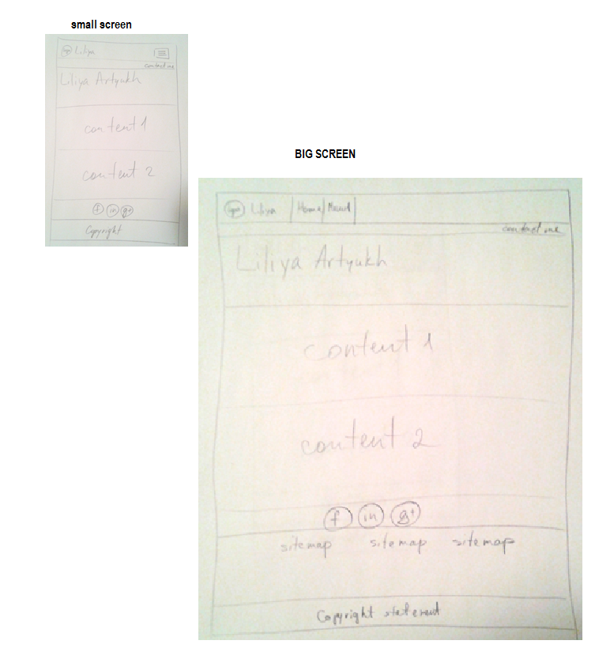

## Mobile Website

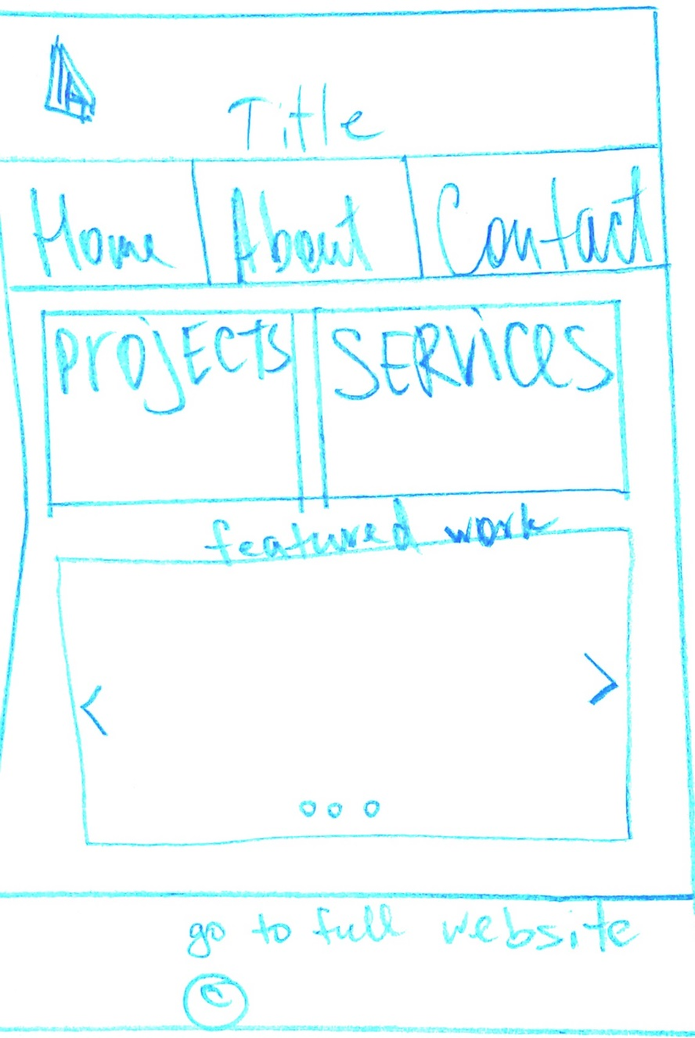

# Branding

Logo

|  |  |
| --- | --- |
| **code** | **example** |
|  | **E:\111 winter 2015\Emerging technologies\portfolioWebsite\images\logo_small.png** |
|  |

## Services page

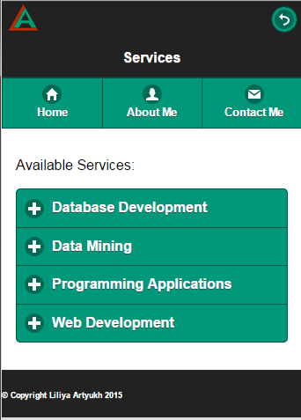

## About Me page

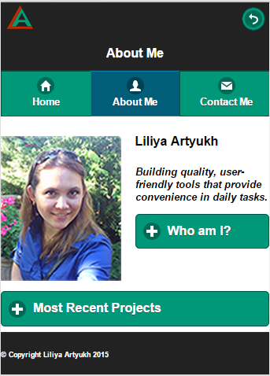

## Contact Me page

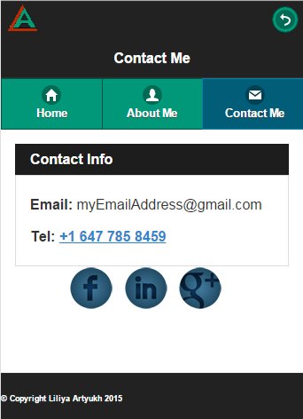

## Home Page

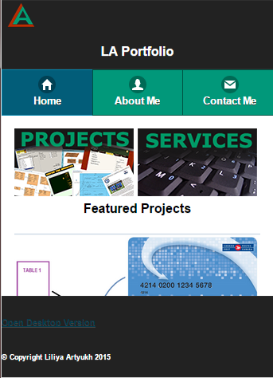

# GitHub

The source files can be found on GitHub. The webste itself is also hosted on GitHub.

Link to the GitHub: <https://github.com/liliya0artyuh/liliya0artyuh.github.io>

Link to website: <http://studentweb.cencol.ca/lartyukh/index.html>

# References

Slider

<http://excolo.github.io/Excolo-Slider/>

ThemeRoller

<http://themeroller.jquerymobile.com/>

jQuery Mobile

<http://demos.jquerymobile.com/1.4.0/rwd/>